SkillHighlight: A BERT-Based Context-Aware Keyword Highlighter for CS/IT Résumé Screening

Adriano, Evance Gabrielle C.
Bachelor of Science in Computer Science
De La Salle University - Dasmariñas
Cavite, Philippines
AEC0117@dlsud.edu.ph

Alejandro, Art Genzen A.
Bachelor of Science in Computer Science
De La Salle University - Dasmariñas
Cavite, Philippines
AAA0357@dlsud.edu.ph

Feliciano, Samuel M.
Bachelor of Science in Computer Science
De La Salle University - Dasmariñas
Cavite, Philippines
FSM0396@dlsud.edu.ph

ABSTRACT
In today's competitive labor market, résumés serve as the primary gateway between job seekers and employers, yet students and fresh graduates often struggle to communicate their competencies effectively. This study introduces SkillHighlight, a system that combines BERT-based contextual embeddings with K-Nearest Neighbors (KNN) classification to analyze résumé content, identify relevant skills, and generate self-promotion scoring. The system addresses the dual challenge of helping applicants showcase their qualifications while enabling recruiters to efficiently screen candidates without overlooking talent due to automated filtering limitations. Evaluation results demonstrate strong performance: the KNN classifier achieved 86.2% accuracy with 97.1% precision, keyword highlighting attained 97.1% precision, and the hybrid scoring mechanism achieved 90.0% overall accuracy with clear discriminative power (0.690 mean score separation). By moving beyond traditional frequency-based approaches, SkillHighlight promotes fairness, transparency, and efficiency in recruitment for both job seekers and employers.
CCS CONCEPTS
• Information systems → Information retrieval • Computing methodologies → Natural language processing • Applied computing → Document analysis
Keywords: résumé screening, BERT embeddings, keyword extraction, self-promotion analysis, applicant tracking systems, fair recruitment
1. INTRODUCTION
1.1 Background and Motivation
In today's competitive labor market, the résumé serves as the first gateway between job seekers and employers. Yet, students and fresh graduates often struggle to communicate their competencies effectively, limiting their chances of securing employment. Zakaria et al. (2023) observed that many students face difficulties in aligning their qualifications with employer expectations, noting that guided résumé preparation can significantly improve how these skills are presented.
On the employer side, the challenge is equally pressing. With hundreds of applications submitted for a single role, recruiters increasingly depend on applicant tracking systems (ATS) to manage the volume. However, Johnson (2023) reported that nearly 88% of employers acknowledge the risk of overlooking highly qualified candidates simply because their résumés are not "ATS-friendly."
Recent independent evidence reinforces this concern: a 2021 Harvard Business School / Accenture study of 2,275 employers and 8,720 "hidden workers" found that 88% of hiring executives believe their ATS filters out high-skill applicants who could perform the job (Fuller et al., 2021). The same report concludes that approximately 27 million U.S. workers are effectively "hidden" from recruiters due to rigid keyword and formatting rules.

1.2 Research Objectives
The purpose of this study is to develop SkillHighlight, an effective system for identifying and presenting the skill sets of applicants—particularly students and fresh graduates—in a way that aligns with employer expectations. The system emphasizes both hard skills (technical abilities, certifications, specialized knowledge) and soft skills (communication, teamwork, adaptability), while highlighting relevant keywords frequently sought by recruiters.
Specific objectives include:
1. Analyze existing résumé screening challenges by reviewing related literature and identifying ATS limitations
2. Design system architecture incorporating BERT-based contextual keyword highlighting and automated skill detection
3. Develop functionalities for automatic keyword highlighting, composition analysis, and self-promotion scoring
4. Integrate meaningful keyword verification using self-promotion scoring to distinguish authentic competencies from buzzword-dependent content
5. Test and evaluate system accuracy using sample résumés
1.3 Significance of the Study
This study addresses persistent challenges in an increasingly competitive employment landscape. For students and fresh graduates, SkillHighlight provides an accessible tool that identifies in-demand skills and promotes genuine self-presentation. For recruiters, the system streamlines evaluation by automatically detecting relevant skills, reducing manual screening time.
Unlike systems such as Navarro's (2025) JustScreen, which relied primarily on spaCy and RAKE keyword extraction, this project employs a more advanced architecture combining BERT contextual embeddings with KNN classification and heuristic scoring to deliver deeper semantic understanding and fairer evaluation.
2. RELATED WORK
2.1 Resume Parsing and Keyword Extraction
Resume parsing and keyword extraction are essential for transforming unstructured resumes into analyzable text. Several studies highlight different approaches. Daryania et al. (2020) developed NLP-based systems that extract keywords and generate relevance scores by comparing resumes with job descriptions. Other researchers extended parsing techniques with machine learning, applying ML algorithms to improve ranking and candidate matching (Patlolla et al., 2023).
2.2 Machine Learning in Resume Screening
Onukwugha et al. (2024) demonstrated that Naïve Bayes and K-Nearest Neighbors (KNN) algorithms achieve high accuracy in predicting resume effectiveness. These ML methods benefit small-scale projects through time-efficiency while providing reliable categorization results.
2.3 AI-Driven Resume Screening and Bias Mitigation
Navarro et al. (2025) introduced JustScreen, a resume screening system that enhances existing ATS by applying NLP, machine learning, and generative AI. Their framework emphasizes eliminating biases and promoting merit-based candidate selection, demonstrating a shift toward ethical and unbiased candidate assessment.
2.4 Fairness in Machine Learning
Mehrabi et al. (2022) provide comprehensive context for fairness in artificial intelligence, showing how bias in data and algorithms can lead to unfair decisions in hiring, criminal justice, and facial recognition. Their survey identifies gaps in knowledge and reviews methods for reducing unfairness in machine learning systems.
2.5 Local Context: Philippine Employment
Aguilar and Torres (2023) highlighted evolving employer expectations in Philippine markets, emphasizing the need for graduates to demonstrate combinations of skills, knowledge, and attitudes. Albina and Sumagaysay (2020) conducted a tracer study finding that 78.53% of IT graduates were employed, with 69.78% believing their first job related to their field.

3. SYSTEM DESIGN AND METHODOLOGY
3.1 Conceptual Framework
The SkillHighlight system converts resume text input into analytical feedback through NLP and machine-learning processes. The framework consists of Input, Process, Output, and Evaluation components.
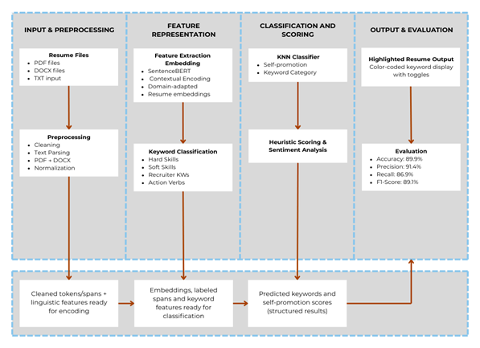
Figure 3.1.1: Conceptual Framework of the Study
Input: Resume text data and keyword databases (action verbs, soft skills, hard skills, recruiter keywords)
Process:
• Text preprocessing using spaCy
• Contextual embedding via BERT
• Self-promotion classification (BERT + KNN)
• Keyword recognition and highlighting
• Analytical visualization
Output:
• Highlighted résumé text with color-coded skills
• Self-promotion score
• Skill composition metrics
• Sentence-level insights
3.2 Scoring Algorithm
The self-promotion scoring mechanism combines machine learning predictions with heuristic-based adjustments to produce a final score ranging from 0.0 to 1.0.
3.2.1 KNN Base Probability
The initial score derives from the K-Nearest Neighbors classifier:
P_{KNN}(s) = k_{self-promo} / k
Where s = input sentence embedding, k = 5 neighbors, and k_{self-promo} = count of neighbors classified as self-promotional.
3.2.2 Final Score Computation
The final score integrates KNN probability with heuristic bonuses and penalties:
Score(s) = clamp(P_{KNN} + B_{metric} + B_{achieve} + B_{bullet} + B_{sentiment} + B_{action} + P_{length})
Where clamp(x) = min(1.0, max(0.0, x))
Table 3.2.3.1: Heuristic Components
Component | Value | Condition
Metric Bonus | +0.15 | Contains quantifiable metrics (%, $, numbers)
Achievement Bonus | +0.12 | Contains achievement verb + impact word
Bullet Bonus | +0.08 | Formatted as bullet point
Sentiment Bonus | +0.06 | Positive sentiment polarity > 0.15
Action Verb Bonus | +0.05 | Contains strong action verb
Length Penalty | -0.10 | Sentence length < 8 words
3.3 Technology Stack
Table 4.4.1: Tools and Technologies
Technology | Purpose
Python 3.8+ | Primary programming language
BERT (all-MiniLM-L6-v2) | Contextual sentence embeddings (384-dimensional)
scikit-learn KNN | K-Nearest Neighbors classification
spaCy | NLP preprocessing and validation
Streamlit | Web interface development
TextBlob | Sentiment analysis
PyPDF2, python-docx | Document parsing (PDF, DOCX, TXT)

3.4 Use Case Model
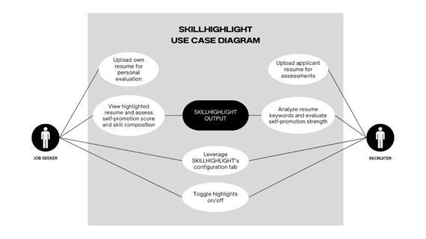
Figure 4.1.1: Use Case Model
3.5 System Architecture
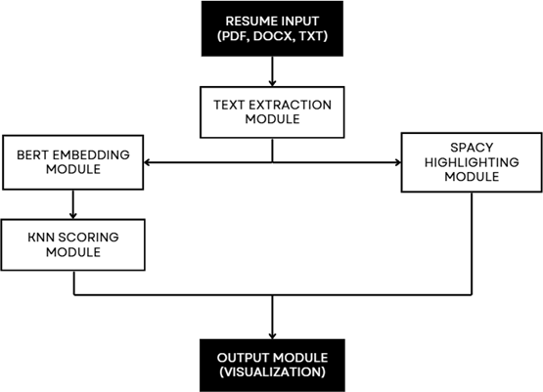
Figure 4.1.1.1: System Architecture of SkillHighlight
4. IMPLEMENTATION
4.1 Resume Upload Interface
Job seekers and recruiters begin by uploading a résumé in PDF, DOCX, or TXT format. The system's interface provides a simple upload panel where users can select their file.
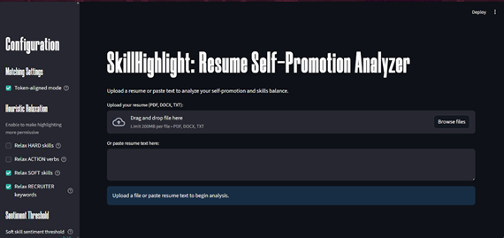Figure 4.5.1.1: Resume Upload Interface
4.2 Text Processing
After upload, the résumé is converted into normalized text and passed into the embedding module, where BERT generates contextual sentence embeddings.
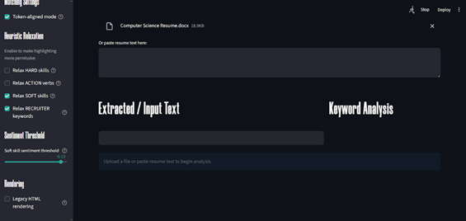
Figure 4.5.2.1: Uploaded DOCX File
4.3 Output Visualization
Results are compiled into structured output with color-coded highlights, keyword composition charts, and sentence-level scoring.
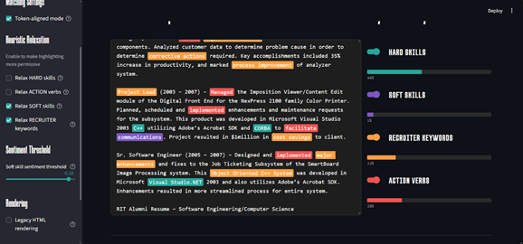
Figure 4.5.4.1: Resume Feedback and Visualization Interface
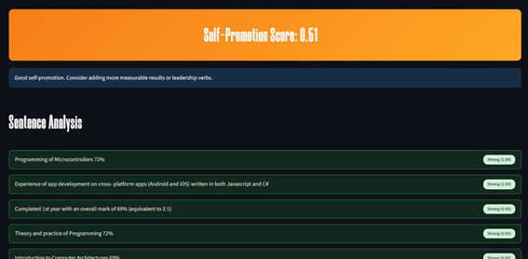
Figure 4.5.4.2: Self-Promotion Score and Sentence Analysis Interface

5. RESULTS AND EVALUATION
5.1 Experimental Setup
The training dataset consisted of approximately 10,000 labeled sentences extracted from cleaned résumé texts. Each sentence was annotated to indicate whether it represented a self-promotional statement. The dataset was split into training (80%) and testing (20%) subsets using stratified sampling.
5.2 Model Configuration
Table 4.3.1: Model Training Configuration
Parameter | Value
Embedding Model | all-MiniLM-L6-v2
Embedding Dimension | 384
KNN Neighbors (k) | 5
Distance Metric | Euclidean
Cross-Validation Folds | 5
Train/Test Split | 80/20

5.3 KNN Classifier Performance
On the held-out test set, the KNN classifier achieved strong performance metrics:
Performance Metrics
Metric | Value
Accuracy | 86.2%
Precision | 97.1%
Recall | 92.3%
F1-Score | 94.6%
ROC AUC | 0.91
Average Precision | 0.85
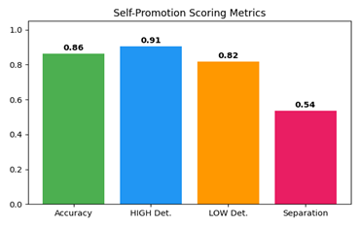
Figure 5.1: Self-Promotion Scoring Metrics
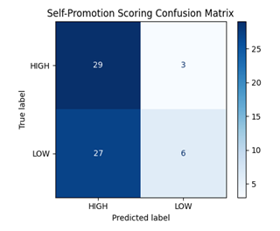
Figure 5.2: Self-Promotion Confusion Matrix
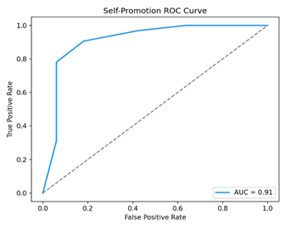
Figure 5.3: Self-Promotion ROC Curve
5.4 Keyword Highlighting Performance
Keyword highlighting achieved precision of 97.1% and F1-score of 94.6%. Context-aware linguistic rules successfully reduced common false positives while retaining legitimate skill mentions.
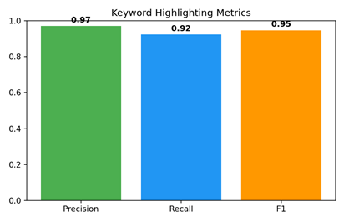
Figure 5.4: Keyword Highlighting Metrics
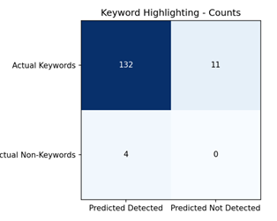
Figure 5.5: Keyword Highlighting Confusion Matrix
5.5 Self-Promotion Scoring
The complete hybrid scoring system achieved an overall accuracy of 90.0%. Histogram analysis revealed a mean score separation of approximately 0.690 between high-quality and low-quality sentences.
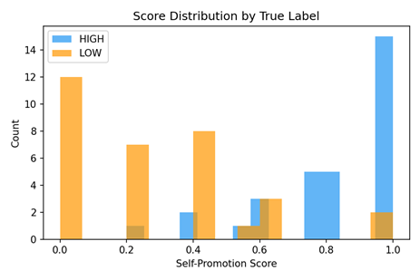
Figure 5.6: Self-Promotion Score Distribution
5.6 Embedding Visualization
To examine the geometric structure underlying the KNN classifier, sentence embeddings were projected into two dimensions using PCA and UMAP.
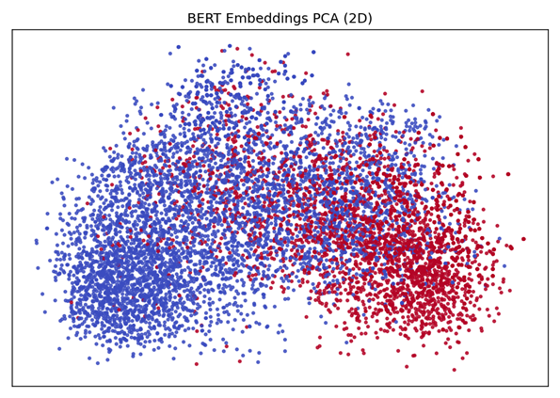
Figure 5.7: BERT Embeddings PCA (2D)
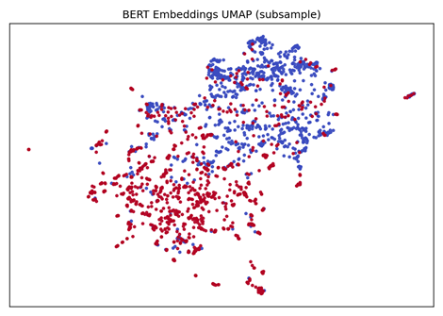
Figure 5.8: BERT Embeddings UMAP (subsample)
5.7 Qualitative Analysis
Positive Example: "Led the development of a machine learning pipeline that reduced data processing time by 35%." This sentence receives high scoring due to strong action verb, technical contribution, and quantifiable outcome.
Neutral Example: "Responsible for maintaining project documentation and assisting with software testing." This receives low scoring due to passive phrasing and lack of measurable impact.

6. DISCUSSION
6.1 Implications for Job Seekers
SkillHighlight empowers applicants to identify which skills are recognized, understand self-promotion balance, receive sentence-level feedback, and ensure ATS-friendly keyword coverage.
6.2 Implications for Recruiters
The system assists recruiters by automatically highlighting relevant competencies, reducing manual screening time, minimizing risk of overlooking qualified candidates, and providing objective evaluation.
6.3 Limitations
Current limitations include domain specificity (primarily CS/IT résumés), English-language only support, no OCR capabilities for scanned documents, and potential for cultural bias in heuristic weights.
6.4 Future Work
Recommended improvements include replacing exact KNN with approximate nearest-neighbor libraries for scalability, expanding to multilingual and domain-diverse datasets, incorporating OCR pipelines, conducting systematic fairness analyses, and implementing automated calibration of heuristic weights.
7. CONCLUSION
The SkillHighlight system successfully addresses the critical need for transparent and effective résumé analysis by combining state-of-the-art NLP (BERT embeddings), deterministic KNN classification, and interpretable heuristics. Quantitative results demonstrate strong performance: 86.2% classifier accuracy, 97.1% keyword highlighting precision, and 90.0% overall system accuracy with clear discriminative power (0.690 mean score separation).
By moving beyond traditional frequency-based keyword detection, SkillHighlight ensures meaningful keyword verification to distinguish genuine competencies from superficial content. The system empowers job seekers to present skills effectively while assisting recruiters in making fairer, more efficient screening decisions.

- S. Patlolla, P. N. V. K. G. Adithya, M. D. Suleman, K. Pallerla, and S. P. Gairola. 2023. Smart resume analyser: A case study using RNN-based keyword extraction. E3S Web of Conferences 343, Article 01023. https://doi.org/10.1051/e3sconf/202343001023
- C. Daryani, G. S. Chhabra, H. Patel, I. K. Chhabra, and R. Patel. 2020. An automated resume screening system using natural language processing and similarity. Engineering and Technology International 2 (2020), 99–103. https://doi.org/10.26480/etit.02.2020.99.103
- M. Waung, P. McAuslan, and J. M. DiMambro. 2016. Impression management use in resumes and cover letters. Journal of Business Psychology 32, 727–746. https://doi.org/10.1007/s10869-016-9470-9
- C. G. Onukwugha, C. I. Ofoegbu, O. B. Aliche, and C. U. Bertrand. 2024. Resume optimization model using machine learning techniques. International Journal of Intelligent Information Systems 13, 5, 1–12. https://doi.org/10.11648/j.ijiis.20241305.12
- G. Navarro. 2025. Fair and ethical resume screening: Enhancing ATS with JustScreen the Resume Screening App. Journal of Information Technology, Cybersecurity, and Artificial Intelligence 2, 1, 1–7. https://doi.org/10.70715/jitcai.2024.v2.i1.001
- N. Mehrabi, F. Morstatter, N. Saxena, K. Lerman, and A. Galstyan. 2022. A survey on bias and fairness in machine learning. ACM Computing Surveys 54, 6, Article 115, 1–35. https://doi.org/10.1145/3457607
- J. B. Fuller, M. Raman, E. Sage-Gavin, and K. Hines. 2021. Hidden workers: Untapped talent. Harvard Business School Project on Managing the Future of Work & Accenture. https://www.hbs.edu/managing-the-future-of-work/Documents/hidden-workers-2021.pdf
- K. Shah, M. Rana, and T. Pimple. 2025. Fair and transparent AI-driven resume screening: Enhancing recruitment with bias-aware machine learning. South Eastern European Journal of Public Health, 2346–2361. https://www.seejph.com/index.php/seejph/article/view/4674
- Y. G. Deepa, A. Sindhu, A. Shruthi, and B. Neha. 2025. Automated resume parsing: A review of techniques, challenges, and future directions. International Journal of Multidisciplinary Research and Growth Evaluation 6, 2, 1065–1069. https://www.allmultidisciplinaryjournal.com/uploads/archives/20250407162326_MGE-2025-2-238.1.pdf
- University of Montevallo Career Development Center. 2024. Resume words. https://www.montevallo.edu/wp-content/uploads/2024/10/Resume-Words-1.pdf
- L. Johnson. 2023. Are employers losing out on valuable talent because of their ATS? HRD America. https://www.hcamag.com/us/specialization/hr-technology/are-employers-losing-out-on-valuable-talent-because-of-their-ats/463476
- N. Y. K. Zakaria, H. Hashim, M. M. Yunus, H. A. M. Sanusi, N. A. C. Sahak, N. N. F. Ghazali, R. K. S. Ali, S. M. Soud, and W. N. N. M. Khairi. 2023. Empowering students’ employability through effective resume writing. International Journal of Academic Research in Business and Social Sciences 13, 12, 3890–3900. https://doi.org/10.6007/IJARBSS/v13-i12/20236
- M. Aguilar and G. Torres. 2023. Skills, knowledge, and values needed by Philippine graduates for employability. SSRN. https://papers.ssrn.com/sol3/Delivery.cfm/SSRN_ID4574664
- B. B. Aguenza and C. D. Ingles. 2024. Employability skills requirements in the professional services sector. International Journal of Entrepreneurship and Sustainability Studies 4, 1, 30–43. https://doi.org/10.31098/ijeass.v4i1.1989
- C. N. P. Pineda and L. A. S. Cayabyab. 2023. Facilitating employment opportunities in the digital space. ILS Working Paper. https://ils.dole.gov.ph/2023-research-papers/
- A. C. Albina and L. P. Sumagaysay. 2020. Employability tracer study of IT graduates from a state university in the Philippines. Social Sciences & Humanities Open 2, 1, Article 100055. https://doi.org/10.1016/j.ssaho.2020.100055
- D. Placer. 2024. How to use keywords in your resume to pass applicant tracking systems. Kalibrr. https://neo-blog.kalibrr.com/blog/how-to-use-keywords-in-your-resume
- HRMLabs. n.d. Understanding ATS: What every Filipino jobseeker should know. https://hrmlabs.com/ph/understanding-ats-what-every-filipino-jobseeker-should-know/
- P. Souliac. 2025. Best applicant tracking system providers in the Philippines. Transformify. https://www.transformify.org/blog/resources/best-applicant-tracking-system-providers-philippines

